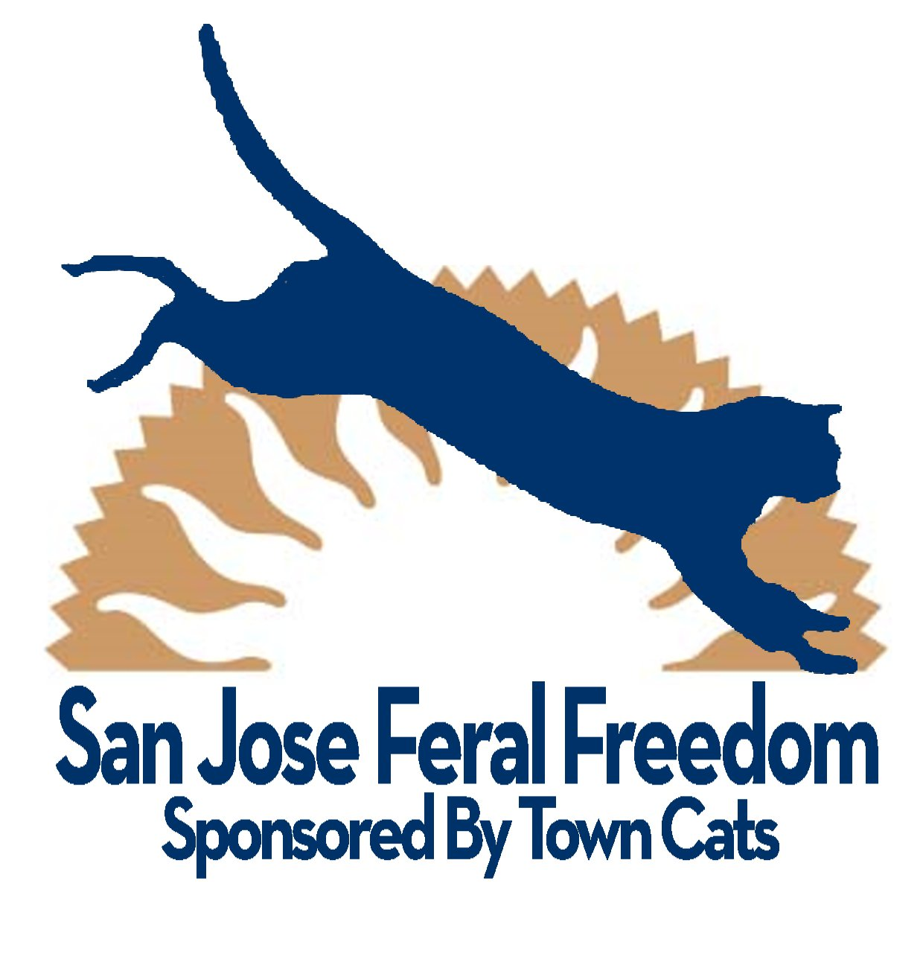

P# _____________

FERAL FREEDOM
VOLUNTEER REGISTRATION

Thank you for your interest in becoming a Feral Freedom volunteer. Town Cats is providing insurance coverage for all Feral Freedom volunteers (as a separate program from standard Town Cats volunteering). As part of this registration, we may conduct a background check to ensure that you have a valid driver’s license and no criminal history.

Today’s date: |  |  |  |  | Do you have a SJACS P#: |  |  |  | YES ◻ NO ◻
Name |  |  |  |  | Do you have a GPS? |  |  |  | YES ◻ NO ◻
Mailing address |  |  |  |  | Work phone
 |  |  |  |  | Home phone
 |  |  |  |  | Cell phone
Contact email |  |  |  |  | Over 18 yrs old?
Physical limitations? |  |  |  |  | Allergies
Contact in case of emergency: Name/phone
Drivers license |  |  |  |  | Expiration Date:
Have you ever been convicted of a crime? |  | YES ◻ NO ◻ | If yes, please describe:

RELEASE/WAIVER OF LIABILITY

I assume the risks of being bitten, scratched, injured, or frightened by cats or kittens in connection with the Feral Freedom Program. Feral Freedom / Town Cats is not liable to me for any injuries, damages, liabilities, losses, judgments, cost or expenses whatsoever, which I might suffer or sustain in connection with the activities of the Feral Freedom program. I will indemnify, defend and hold Town Cats harmless from and against any claims, lawsuits, injuries, damages, losses, costs or expenses whatsoever, sustained by any companion animal or any person in connection with Feral Freedom.

I will abide by the rules, regulations, policies and programs of Feral Freedom.

THE UNDERSIGNED HAS READ AND VOLUNTARILY SIGNS THE RELEASE & WAIVER OF LIABILITY AGREEMENT, and further agrees to no oral representation, statements or inducement apart from the forgoing written agreement that has been made.

Signature |  | Date

BACKGROUND CHECK

I do hereby authorize Feral Freedom/Town Cats to secure background information on my criminal history and driving record and other matters related to my suitability for this volunteer position. I authorize my references and background sources to disclose information about me to Feral Freedom/Town Cats, without giving me prior notice of such disclosure. I hereby release Feral Freedom/Town Cats and all other sources from any and all claims, demands, or liabilities arising out of or in any way related to securing such information or disclosures. I give my consent that a photocopy of this authorization be accepted with the same authority as the original.

Signature |  | Date

